*Florida International University*

*School of Computing and Information Sciences*

CIS 4911 - Senior Capstone Project

Software Engineering Focus

Final Deliverable

Strategic Marketing Simulator 1.0

Team # 15

**Team Members**

Jeffrey Carman

Javier Andrial

**Product Owner**: First Name Last Name

**Instructor**: First Name Last Name

Copyright and trademark notices, restrictions on copying or distributing the documentation, information for contacting the issuing organization (reader’s comments), warranties, contractual obligations or disclaimers, and general warnings and cautions.

***Abstract***

*Students of the FIU business school take marketing courses to give them a solid understanding of business activities as they relate to target markets, development of pricing models, the promotion of goods and services, the management of business relationships and consumer behavior. Much of the curriculum is theory as it pertains to marketing concepts, but there is something lacking. The subject application, Strategic Marketing Simulator, allows students and instructors to participate in a mockup of a hotel market, where the way a marketing budget is allocated and the state of the market has a direct impact on how the market trends during an interval of time, a period. Additionally, students gain an understanding on how political and social policy, force majeure, supply and demand etc., can affect one company's market share over another.*

**Table of Contents**

**Introduction**

Current System

Purpose of New System

**User Stories**

Implemented User Stories

Pending User Stories

**Project Plan**

Hardware and Software Resources

Sprints Plan

*Sprint 1*

**System Design**

Architectural Patterns

System and Subsystem Decomposition

Deployment Diagram

Design Patterns

**System Validation**

**Glossary**

**Appendix**

Appendix A - UML Diagrams

*Static UML Diagrams*

*Dynamic UML Diagrams*

Appendix B - User Interface Design

Appendix C - Sprint Review Reports

Appendix D - Sprint Retrospective Reports

**References**

# Introduction

University instructors need a means for having their students run simulations of a hotel room sales market to show the impact that different marketing budget allocations will have on the market. These allocations need to take the form of dollars spent on marketing personnel, advertising, and promotions; along with type of hotel and the location of the hotel. The way a student utilizes their budget will ultimately affect the market by either giving him or her competitors a market advantage. By the same token, these students need a means for interpreting the effects of budget allocations that other students have in the same market. Finally, instructors need a way to track these results over varying intervals of time.

## Current System

The current system of simulation is done through conversation and debate between students and instructor in a classroom setting. The instructor poses scenarios about trends in the market and asks students for their input about how a marketing budget allocation might affect the market. The system is limited by the subjective point of view of the instructor in that there is no mathematical formula being deployed to make a decision about how an allocation might affect market status and/or future trends. This system takes a lot of time to implement and is difficult to continue the same conversation from one class period to another.

## Purpose of New System

The Strategic Marketing Simulator allows students to make marketing decisions that will affect the hotel sales market in a simulation application. “Decisions” are defined by the system as a number of marketing budget items which are allocated in the form of dollars spent on marketing personnel, advertising, and promotions. Each type of decision carries a different ranking, which is quantified in a meaningful way by the system to produce an impact on the market. The market status, as displayed by the simulation, will change as a result of actors on the simulation, market trends, and current events. The actors on the simulation are other students and/or programs which simulate students by randomly selecting budget allocations (decisions) which affect the market in a similar way. At the end of each period, a user can view the current state of the market, their remaining budget, and the rankings of all the other actors. At any time, an instructor can view the results of all periods and the final results of a game. At the end of a game, all users can see the outcome of the game which can foster conversations about how a market can be affected by marketing investments.the same way. At the end of each period, a user can view the current state of the market, their remaining budget, and the rankings of all the other actors. At any time, an instructor can view the results of all periods and the final results of a game.

# User Stories

In this section a list of user stories are presented. Use stories are a means for defining the required functionality and behavior of the system and how a user can manipulate the system to perform a desired task. The user stories for the Strategic Marketing Simulator come in two forms: student user stories and admin stories. Both describe how each will interact with the system to play a game or administrate over a game (respectively)

## Implemented User Stories

**User Story # X - Story Name**

**User Story # X - Story Name**

Text of the story.

…

## Pending User Stories

**User Story # 718 - Manage Page**

* As a logged in admin I need to be able to navigate to the manage page so that manage users, manage games, and manage administration
* A logged in admin clicks on the manage link
* The admin can manage users, games and administration.

**User Story # 712 - User comment and commit**

* As a logged in user I need be able to commit period budget allocation so that I can move to the next period.
* A user clicks the “commit budget allocation” from the Strategic Decisions Page.
* A comment text box appears.
* The user types in reason for his or her decisions and clicks the “commit” button

**User Story # 711 - Delete Users**

* As a logged in admin I need to be able to delete users so that I can remove users from the system
* A logged in admin clicks, delete user.
* A confirmation dialog box appears. the admin clicks “yes”
* The user account is deleted from the system

**User Story # 710 - User Toolbar**

* As a logged in user I need to be able to access the toolbar from any page
* A logged in user can view the toolbar from any page of the system.
* The toolbar contains links for the following pages:
  + A Home. this button goes to the Home page
  + Metrics. this button goes to the Metrics Page
  + Strategic Decisions. this button goes to the Strategic Decisions page
  + News. this button goes to the news Page.
  + Manage. this button will only be visible for Instructor/admin users
    - this button goes to the Manage page.

**User Story # 709 - Admin News**

* As a logged in administrator I need be able to add a news story to the system so that the users can make informed decisions about current events
* A logged in admin clicks on the add news button,
* The admin enters the text for the article and checks some or all of the following check boxes:
  + Impact positive
  + Impact negative
  + location
  + hotel type – eco
  + hotel type – lux

**User Story # 708 - User Scorecard**

* As a logged in user I need to be able to access my scoreboard from the homepage of the website
* A logged in user clicks on home like.
* The homepage displays the scorecard to include the following information:
  + Hotel type
  + Location
  + Advertising
  + Room Allocated
  + Remaining Budget
  + Group Name

**User Story # 706 - Admin home page**

* I as a logged in admin need to be able to click the home button so that the system can navigate to my homepage
* A logged in admin click the home link
* The system navigates to the admin home page

**User Story # 704 - Admin Login**

* As an admin I need to be able to log into the system so that I can manage games and users
* An admin navigates to the login page.
* An admin enters his username and password into the corresponding text boxes

**User Story # 689 - Delete Users**

* As a logged in admin I need to be able to click on "create game" from the games page to create a new game
* a logged in admin clicks on create game.
* The system navigates to the create a new game page.
* The admin enters game information for class, section, meeting time, semester, and budget in the corresponding text boxes.
* The admin selects users from a list to add to the game and clicks the create button.

**User Story # 686 - Admin Game Page Functionality**

* As a logged in admin I need to be able to click on a game in progress from the games page so that I can view all the groups that are playing **a** particular game in descending order of game success
* A logged in admin clicks on a game from a list of games on the games page.
* The system populates a listing of all users associated with that game in descending order of success

**User Story # 685 - Admin games page**

* As a logged in admin I need to be able to click on the "games" link from the homepage so that I can view all games that are in progress
* A logged in admin clicks on the “games” link from the toolbar of the home page.
* The populates a list of games that are in progress.

**User Story # 684- Bot creation**

* As a logged in admin I need to be able to create a bot account
* A logged in admin navigates to the create user page
* The admin clicks the create new user button.
* The admin enters the username and group./
* The admin ticks the “is a bot” check box
* The admin clicks the create user button

**User Story # 683- Admin Account Creation**

* As a logged in admin I need to be able to create admin accounts so that other admins can create simulations.
* A signed admin navigates the the create admin page and clicks new.
* The admin enters a username and email address for the new admin.
* The system sends an account verification email to the new admin.

**User Story # 681- Admin “users” page**

* As a logged in admin I need to be able to click on the "users" link from my homepage so that I can see a list of all users
* A logged in in admin clicks on users from the homepage.
* The system navigates to the users page

**User Story # 680- Admin home**

* As a logged in admin I need to be able to click on the "home" button from any page of the system so that the system can navigate to the home page
* A logged in admin clicks on the home link
* The system navigates to the homepage

**User Story # 679- User View news**

* As a logged in user I need to be able to click on the "news" link to view current events so that I can make an informed decision about how to allocate my marketing budget
* user clicks on the news button.
* The system navigates to the new pages
* News articles are listed

**User Story # 678- User strategic decisions**

* As a logged in user, I need to be able to click on "Strategic Decisions" link from the toolbar so that I can assign values to the budgetary items: Marketing personnel, advertising media, room pricing, and third party vendors
* A user clicks on the strategic decisions link.
* System navigates to strategic decisions page.

**User Story # 677- User Metrics**

* A a logged in user I need to be able to click on the "metrics" from the toolbar so that I can view "sales and demand", "Market position", so that I can make informed decisions about budget allocations for future periods
* A logged in user clicks on the “metrics” link on the toolbar to access sales and demand, research results, market info and market position.

**User Story # 676- User home**

* I as a logged in user need to be able to click on the "home" link from any page in the system so that I can navigate to the home page.
* A user clicks on the “home” link.
* The system navigates to the home page.

**User Story # 672- Market Status Graph**

* As a logged in user I need to be able to view the graphs on the dashboard so that I can view a graphical representation of the current market status.
* A logged in user views the graphs on the homepage.

**User Story # 671- User leaderboard**

* As a logged in user I need to be able to access the leader board on the dashboard of the homepage so that I can view my progress compared to other groups.
* A logged in user view the leaderboard to view his or her own statistics and the statistics of all other groups participating in the current simulation.

**User Story # 670- User Dashboard**

* As a logged in user, I need to be able to access the dashboard on my homepage so that I can view the leaderboard, tool bar, and market graphs
* A logged in user views dashboard to include the scorecard, toolbar and market graphs.

**User Story # 668- Password Recovery**

* I as a user need to be able to be able to request a "password recovery email" from the system so that I can recover my password
* A user enters his or her username or email address.
* The system sends the user an email to the user with random password.

**User Story # 667- Forgot my password**

* The user clicks on the “forgot my password” link from the login page.
* The system generates a random temporary password.
* The system sends the use an email with his or her temporary password enclosed.
* The user logs onto the system using the temporary password.
* The system requires that the user reset his password by entering it in two text boxes.
* The user’s password is reset.

**User Story # 669- User login**

* As a user I need to be able to log into the system so that I can view my homepage
* A user enters his or her password and clicks “login”
* The system navigates the the user’s homepage

**User Story # 666- Account Creation**

* As a user, I need to be able to create an account with the system so that I can participate in simulations
* A user enters a username and password into the corresponding text boxes on the login page.
* The user enters his or her email address
* The user click the “Create account” button.

# Project Plan

Provide a one- or two-paragraph overview of this section. You can think of this introductory paragraph as a kind of abstract specific to this section.

## Hardware and Software Resources

Provide a comprehensive list of the hardware and software you will use to develop the system. For each software resource (OS, programming language, framework, development tool, etc) briefly specify the reason for your selection.

## Sprints Plan

For each sprint, list the user stories selected for implementation in descending order of priority.

### Sprint 1

(08/31/2015 - 9/11/2015)

**User Story # 666- Account Creation**

***Tasks***

* Insert database tables for users, groups, and courses (database subsystem).
* Setup blank home page with login link.
* Setup login page (username, password text boxes; “forgot my password”, “new user” links; and login button.
* Setup account creation webpage (username, password, PID, email text boxes; and a list of courses available.
* Setup java class user with getter/setter methods and boolean value for isAdmin.
* Setup Java Database class and methods for updating user and group tables of the database subsystem
* write scripts to tie it all together.

***Acceptance Criteria***

* The username must be unique.
* The PID must be unique
* Password must be alphanumeric
* System sends verification email to user
* The user clicks verification link
* The system verifies user and create entry in the database subsyste*m.*

***Modeling***

See Appendix A

Figure 7: sequence diagram

Figure 9: use case diagram

**User Story # 669- User login**

***Tasks***

* Add methods to java Database class for user login.
* write scripts to communicate with to Database subsystem from front end.
* write scripts to navigate user to homepage upon success.
* Appropriate error message upon value.
* (Future release should have account lockout policy)

***Acceptance Criteria***

* The user must enter a username and password which are associated with a record in the database subsystem.
* ***Modeling***

See Appendix A

Figure 6: sequence diagram.

Figure 8: use case diagram.

**User Story # X - Story Name**

***Tasks***

* List each task as a separate bullet point.
* The collection of tasks in a sprint defines its scope, i.e., the product to be delivered at the end of the sprint.
* The collection of tasks of all sprints defines the scope of the system.
* …

***Acceptance Criteria***

* List verifiable criteria for the acceptability of the implementation of this user story.
* …

***Modeling***

Refer to UML diagrams in Appendix A that were created or modified to model the functionality that will be implemented in this sprint.

**User Story # X - Story Name**

…

# System Design

The Strategic Marketing Simulator is composed of three subsystems. The database subsystem is responsible for all database transactions being made by any class in the system. The other subsystems communicate with the database to perform a variety of tasks such as adding a user record to the database or accesses a value needed for the Market subsystem. The Market subsystem is responsible for interpreting the effect of a group’s strategic decisions on the market. The Market subsystem communicates with the database subsystem to retrieve information about which groups are applying a certain decisions. Once the Market Ranking subsystem has made a determination, it can then pass the values to the Database subsystem storage for later use.

The third subsystem is the Main Controller subsystem. The Main Controller handles the game creation and keeps track of the current periods. The Main Controller subsystem communicates with both the database subsystem and the Market subsystem such that market information stored in the database subsystem can be used in conjunction with the Market subsystem to display market results on a webpage.

## Architectural Patterns

The architectural patterns used in the development of this system were three-tier and model-view-controller patterns. These patterns were adopted because during the requirements elicitation of analysis phase of the project, apparent subsystems began to emerge that have a three-tier like pattern, which has a controller, database, and a graphic user interface. Taking into consideration that emerging pattern and the team’s understanding of the system made the model-view-controller also relevant due to the apparent subsystems’ disconnect between between one another in functionality and requirements.

## System and Subsystem Decomposition

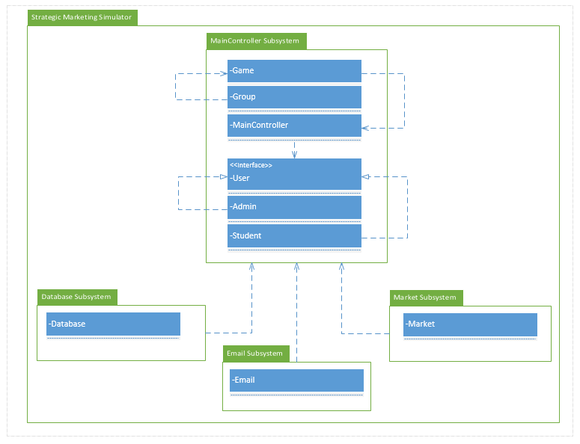

Figure 1: Package Diagram. The Strategic Marketing Simulator system can be decomposed into four subsystems. The MainController subsystem is responsible for creating games, users, and groups. All system input and output is communicated using the MainController subsystem as an intermediate between the front end and the rest of the back end. The second system, the database subsystem is responsible for all database transactions and the storing of game and user data. The third subsystem is the Market subsystem which is responsible for calculating all groups’ Strategic Decisions at the end of each period, and passes values to the MainController subsystem for display on the back end or to be handed to the Database subsystem storage for later use. The fourth subsystem is the Email subsystem, which is responsible for sending emails to users upon account creation and for password reset.

## Deployment Diagram

Using a UML deployment diagram, illustrate which subsystems will reside on each hardware component and show how the different pieces are connected.

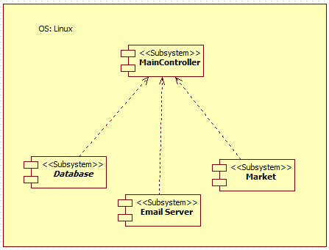

Figure #2 UML Deployment diagram for the three subsystems. All three subsystems are housed on a linux server

## Design Patterns

The Strategic Marketing Simulator is being designed using the mediator design pattern and the private class data design pattern. This was chosen because we want to follow best practices for object oriented programming to make sure that the classes do not expose their instance variables to manipulation by ensuring that all data transactions are being handled by a single intermediate (mainController subsystem) and the classes are all have private access.

# System Validation

Provide a one- or two-paragraph overview of this section. You can think of this introductory paragraph as a kind of abstract specific to this section.

**User Story # X - Story Name**

System Tests

* Test ID - Brief statement of the test purpose.
* …

Subsystem Tests

* Test ID - Brief statement of the test purpose.
* …

**User Story # X - Story Name**

…

# Glossary

Decisive user:

Define any domain-specific terms that the audience of this document may be unfamiliar with. You can assume the audience of this document to be technical savvy. Examples of terms that do not need to be defined are: HTML, CSS, Web Server, DB, and the like.

# Appendix

## Appendix A - UML Diagrams

### Static UML Diagrams



Figure 3: Class diagram

YOU NEED TO ADD ANOTHER OBJECT DIAGRAM HERE AS FIGURE 4

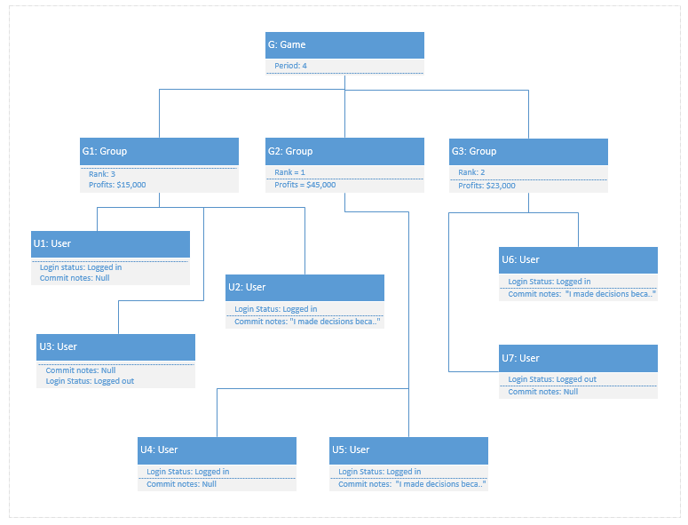

Figure 5: This is an object diagram to illustrate the instance of a Game object and at a the moment when period when period 4 ends. The object Game listed as G above, is connected to its main elements, Groups, which are listed as G1, G2, and G3. The main values associated with each group are Rank, the groups current rank compared to other groups, and profits, the total amount of profits earned based on their strategic decisions. Each group is connected to its main elements, Users, listed as U1, U2..U7 above. Each user have the two main values associated with them: the Login status binary value of either “logged in” or “logged out” and a binary value of “commit notes”, which indicates if that is the *decisive user* for the period.

…

### Dynamic UML Diagrams

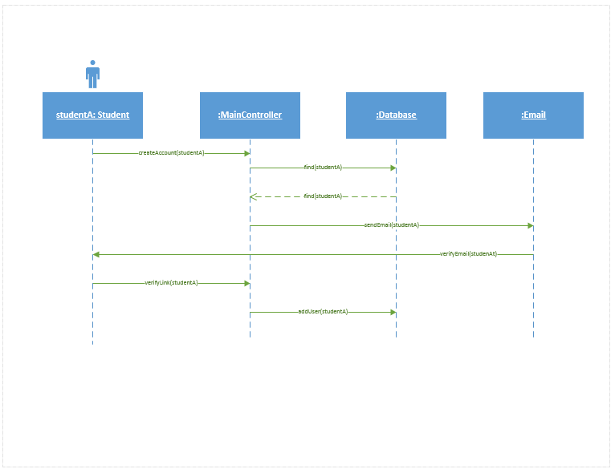

Figure 6: Account creation sequence diagram.

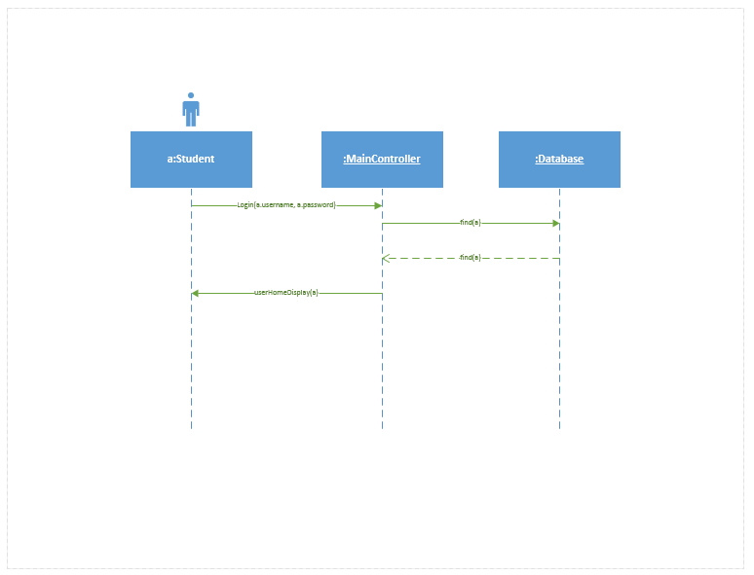

Figure 7: User login sequence diagram

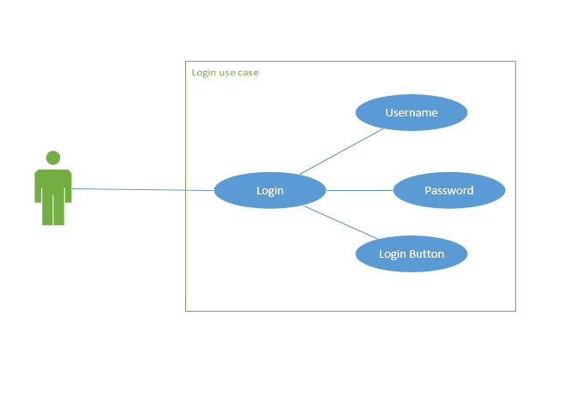

Figure 8: User login use case diagram

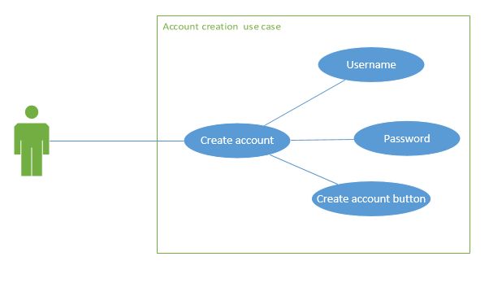

Figure 9: Account creation use case diagram

## Appendix B - User Interface Design

Include screenshots of the user interface of your system. For new versions of existing sytems, include only screenshots of the new or modified aspects of the user interface.

There’s no need for introducing this section.



Figure # - Caption Text

…

## Appendix C - Sprint Review Reports

**Sprint 1 Report**

**Date:** Month Day, Year

**Attendees:** First Name Last Name, First Name Last Name, …

**Discussed Topics:**

Considering the initial goals, cost estimates, and acceptance criteria, briefly explain what was achieved and what was not achieved in this sprint. Specify the reasons for not being able to finish all the work that was initially planned for this sprint. Specify if the product backlog was modified as a result of this meeting and if so, how.

**Sprint 2 Report**

**Date:**

**Attendees:**

**Discussed Topics:**

…

## Appendix D - Sprint Retrospective Reports

**Sprint 1 Retrospective**

**Date:** Month Day, Year

**Attendees:** First Name Last Name, First Name Last Name, …

**Discussed Topics:**

Explain what went well and not so well in this sprint. Include any agreed-upon actions to mitigate any issues for the next sprint.

**Sprint 2 Retrospective**

**Date:**

**Attendees:**

**Discussed Topics:**

…

# References

You must reference any work that is not your own.